****Most Important Points****
1.WE NEED ALL THE CLEAR AND VISIBLE PHOTOS CLICK DURING DAY TIME
2.Please do not remove the below mentioned 9 headings (Photo no.1 to Photo no.9) and paste the original photos instead of sample photos below all the headings
3.In one-word file please send us maximum 12 to 13 photos only.
4.While sending us request please rename the word file name ONLY same as container no. and don’t give any other name. for an example file name must be “BMOU2978465”
5.Subject line of Email: COIL/MMA approval request for Booking reference no.

Container loading plans must include the following details.
1) The lashing/bracing plan
2) How the load will be distributed/divided across the length of the floor. Please include the length and sectional modulus of the bearers to be used.
3) How the cargo will be blocked at front and rear of container so as to prevent motion along the long axis of the container.
4) How the cargo will be blocked/braced to prevent motion along short axis (side-to-side) of the container, to prevent pressure against the corrugation.
5) Pictures showing the proposed arrangement for each point 1) through 4) above.
6) Weight of Coils, number to be loaded into each container and Type of Metal
7) Shipper name, destination, load port and approximate volumes
8) Pictures of actual stuffing, actual container no(s) to be submitted to CENCGOREA for approval of stowage/lashing.

Lashing / securing
1) The maximum payload of the container must not be exceeded, coils are normally shipped in 20ft dry containers, maximum payload is generally 28170 kgs.
2) The cargo weight must be distributed over sufficient length of the container floor to prevent damage to and possible failure of the floor. In a 20ft dry container this means that the weight must not exceed more than 4,870 kgs per meter of floor length. If it does then two wooden timbers should be laid parallel to each other lengthwise along the container floor under the coils The minimum length of the timbers to be used can be calculated by dividing the gross weight (in kilos) of the coil by 4870. If two coils are loaded side by side then the combined weight of the coils must be used in the calculation. See Stuffing for further reference.
e.g. coil weight 10,000 kilos/4870 = 2.05, timbers need to be 205 cms long
3) Coils must not rest directly on the container floor this will damage both the coil and the floor.
4) Coils can be loaded in a number of positions with the eye of the coil (the hole in the middle) facing either to the sky, to the sides of the container or fore and aft (towards the door and the front of the container).
5) Care must be taken to ensure they cannot move inside the container they must be secured adequately to withstand the normal forces encountered during a sea passage. Coils can be lashed using the lashing eyes located along the bottom rail of the container. Each lashing eye can take up to 2mt. Because of their weight in addition to lashing they needed to be braced using timber to prevent movement and excessive pressure against the container walls. Timber bracing used should not be against one single point of the walls but should spread the load evenly over an area of the walls. See Stuffing for further reference.
6) To prevent movement against the container doors a timber bulkhead should be fitted into the slot immediately behind the corner posts and the container doors, this slot is approximately 50 mm wide and should be used rather than the container wall corrugations to hold a bulk head
7) If container is grounded only spreaders may be used. Use of slings or chains is NOT ACCEPTABLE.
Heavy

Heavy cargo
Clause 10 & 12 of the ML Bill of Lading refers to when the shipper is to be held liable for any damages/cleaning costs. Hot rolled steel strip on coils are best handled with "C"-hooks and specially made rounded prongs on a forklift truck. Coils are susceptible to localized bending of the inner and outer circumference edges by use of the wrong handling gear. Fresh water rust is usually not a problem; only superficial.

Steel Coils
Hot rolled steel is not wrapped and is susceptible to the elements. Cold rolled steel is normally wrapped and must be considered delicate material, requiring covered storage and kept dry at all times. Cold Rolled steel must not be subjected to large fluctuating temperatures and/or sudden increases to high relative humidity: sweating of the goods, with resulting damage, may eventuate
See Condensation & Sweat
Photo no.1 The pictures must be clear enough to identify if coils are not touching the floor directly
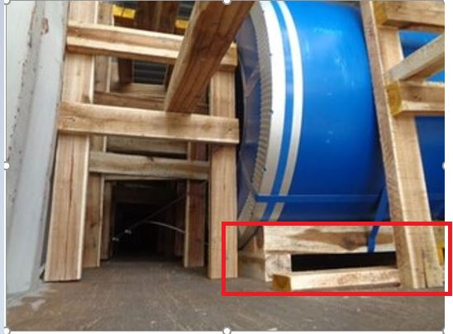

Photo no.2 Both the side secured properly with proper Blocking/bracing
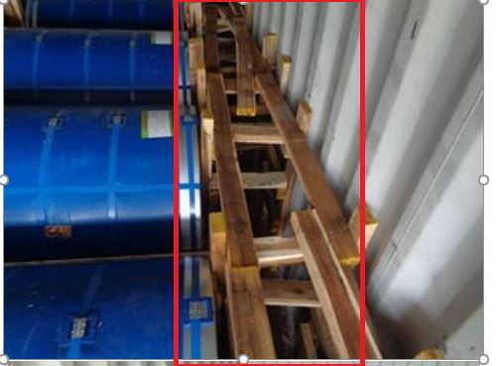

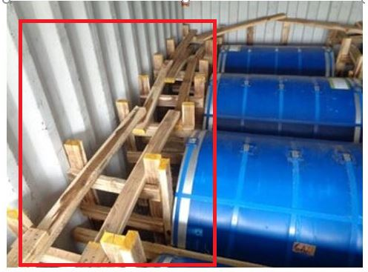

Photo no.3 Last coil in the container is not supposed to touch the container wall
The rear bulkhead with the crossbars needed as the pressure over the whole Container width must be distributed…..Use of only 2 vertical bars are not allowed
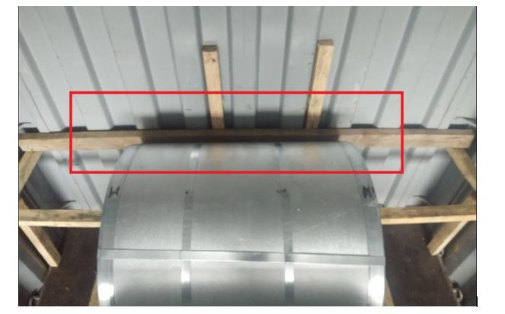
Photo no.4 Coils need to be lashed
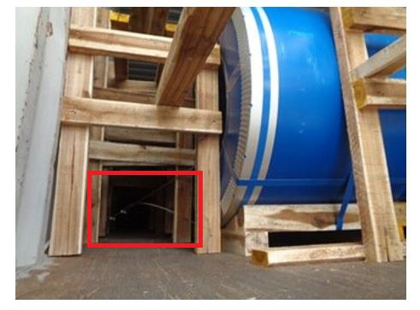
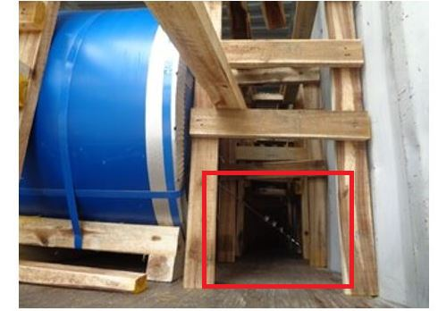

Photo no.5 A. Middle stuffing must be visible

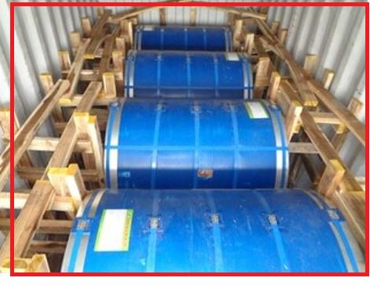

Photo no.5 B. Coil at middle of container is not place on the container floor
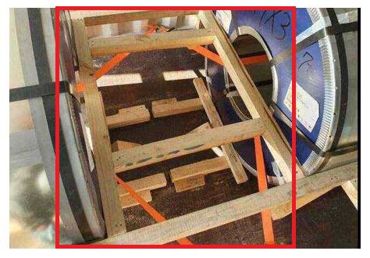

Photo no.6 Wedges need to be put below the coils to prevent it from moving
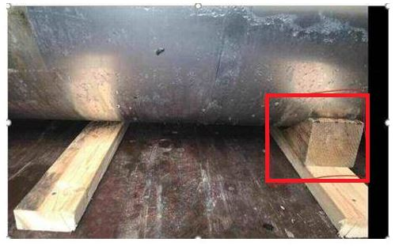
Photo no.7 Solid Bulkhead to be placed at the front rear end to arrest the motion of the commodity to door. Horizontal bars need to be fixed into corrugation of the container walls.
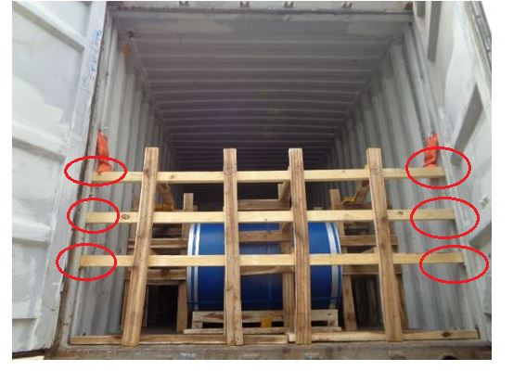

Photo no.8 Please send us clear/visible two door open photograph as we wanted to see full stuffing, (In this two-door open photo complete container must be visible along with its border and edges and the commodity inside must be clearly visible. The photos must be clicked straight and not is any other angle)

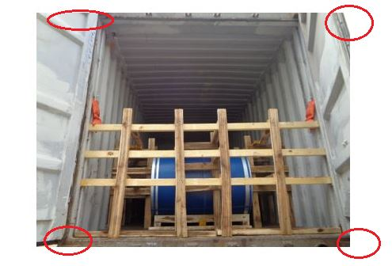

Photo no.9 We need one door shut photograph as in one picture we wanted to see the commodity stuff inside the container + container no. (In this one door shut photo complete container must be visible along with its border and edges and the commodity inside must be clearly visible. The photos must be clicked straight and not is any other angle)
