08/Dec/2020

Easier Online Booking Amendment

Dear Customer,

In our endeavour to provide you with quality services and faster solutions, we have enhanced our online portal so that can easily amend all your booking requests online through our online portal via https://www.maersk.com/

Keeping this in mind, with effect from 01 January 2021 we will not be accepting any manual booking amendment requests through email channel or via calls/chats.

How will this benefit you?

No Email required! Submit your booking amendment request online at www.maersk.com in a few easy clicks. Your request will be processed within 1 business hour ONLY instead of 4 business hours on email. For DG and OOG shipments, timelines may vary depending on complexity of the amendment.

We hope all these recent changes makes it easier for you to do business with us. Should you have any questions, please feel free to contact your local Customer Service representative.

Exceptions – Any Change of Destination requests after container is gated in to be done via email channel .

Refer the below easy step-by-step guide to place an online booking amendment.

Step 1

- Open your Booking on WWW.MAERSK.COM and paste your booking number on “Track”
- Once you land on the shipment binder, under overview, click on AMEND BOOKING to amend your booking as shown below:

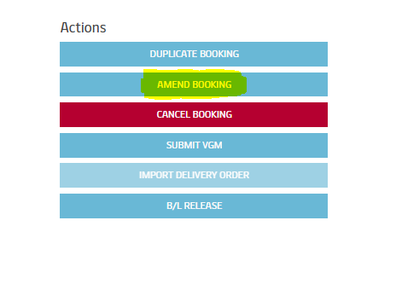

To Amend the Vessel/ETD
- If you wish to Postpone or Prepone the Vessel/ETD, select the vessel ETD as per your requirement
- For example: If the shipment is planned on 09th Sep vessel and you want to roll over the vessel on 16th Sep sailing
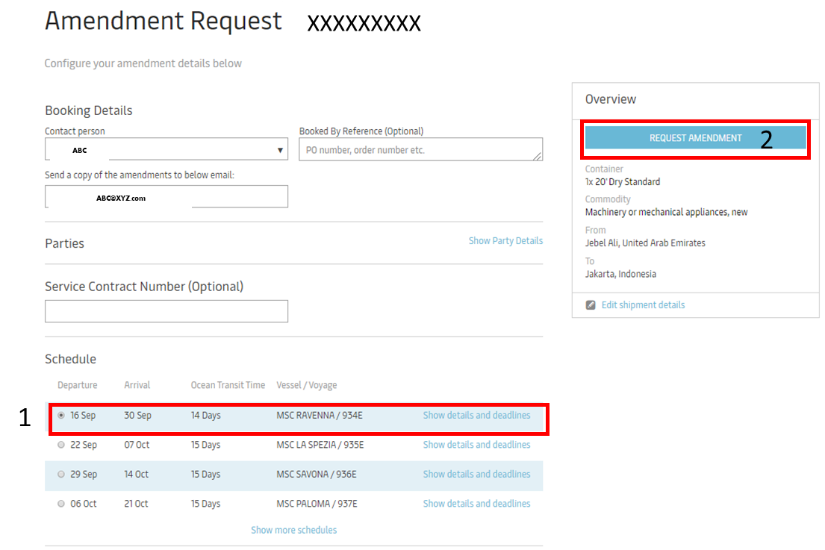

To Amend Equipment details - If you wish to add , modify or remove the equipment details such as Equipment Type/Size/Quantity etc, Click on Edit Shipment details

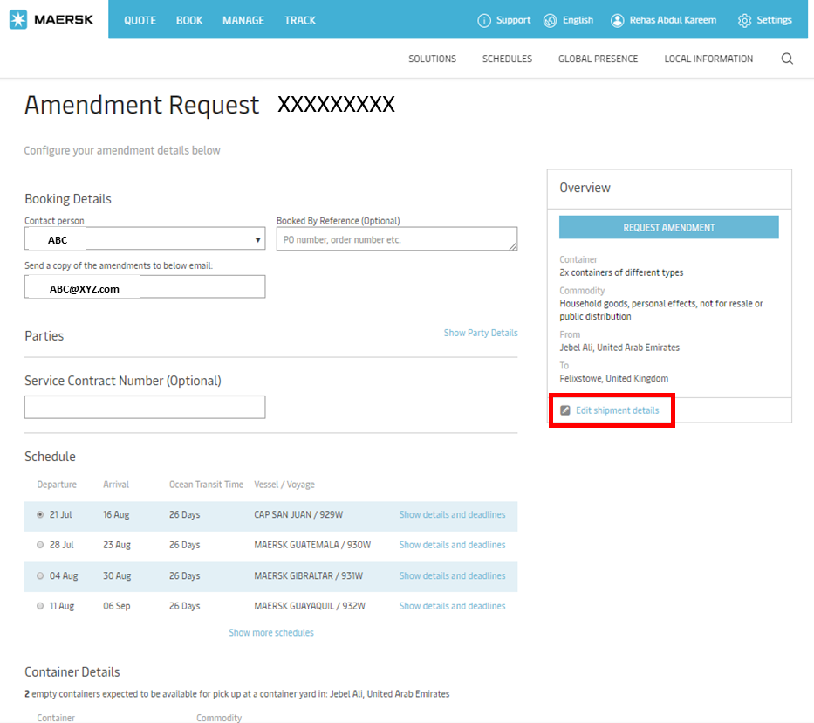

1. To Add Additional Equipment – click on “Add another container type/commodity, make your change, click on continue and then request amendment and then submit amendment.

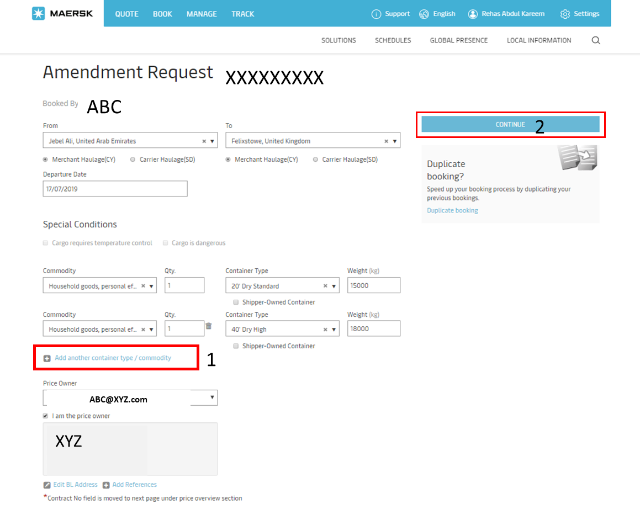
2. To Delete Equipment - click on circled trash icon, make your change, click on continue and then request amendment and then submit amendment.

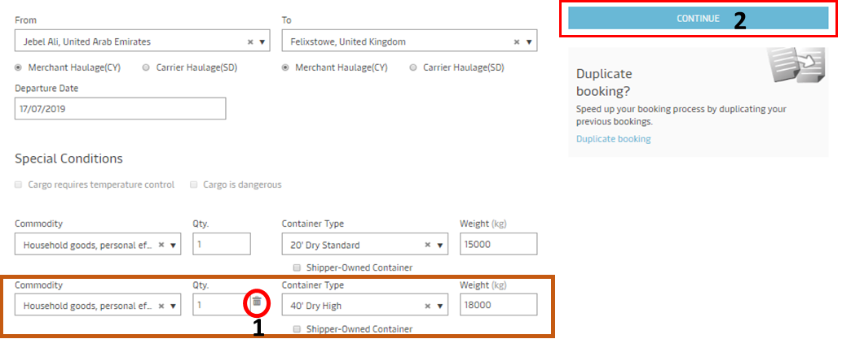

3. To Modiy Container Type – Select desired option from drop down, click on continue and then request amendment and then submit amendment.

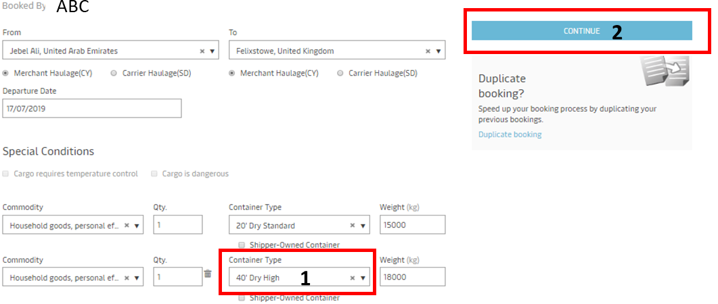

To Add Haulier Code - Select “Show Party Details”, amend shipper reference and update haulier code. Then select Request amendment and submit.

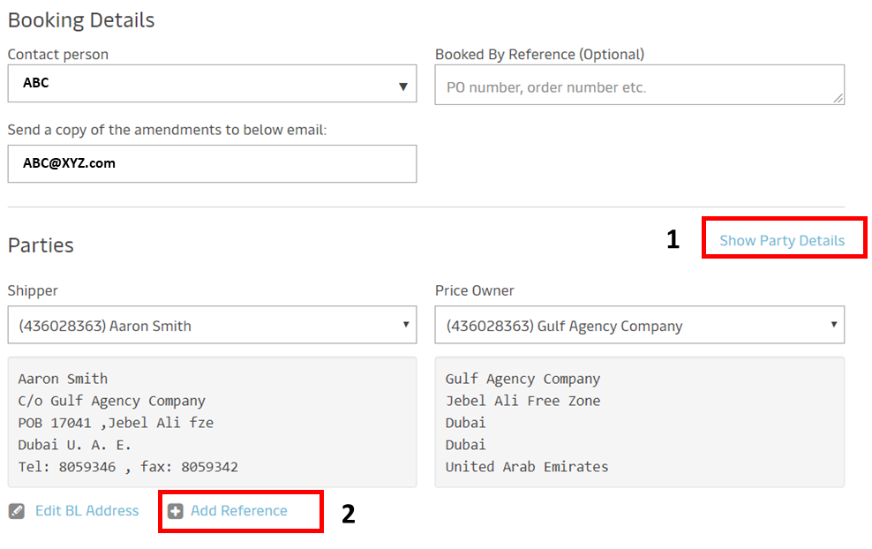
To Amend POD – Click on Edit Shipment Details, select desired POD from dropdown, clikc on continue then request amendment and submit.

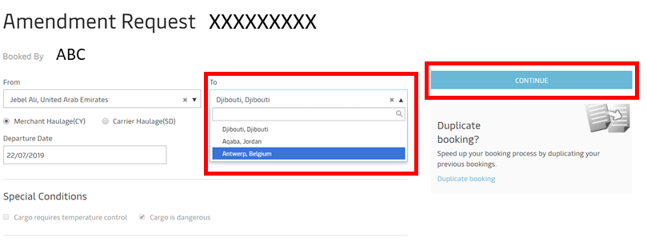

To inform about any additional requirement
- Use the “Additional Comments” free text box for Load port amendments, Flexi, GOH using the exact words. In case if you use any other words, it may delay your amendment request.

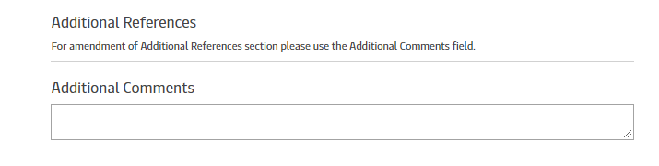

We hope all these recent changes makes it easy for you to do business with us.

Should you have any questions, please feel free to contact your local Customer Service representative.

Thanks for your co-operation as always.

Kind Regards,
Maersk

